
KENBRIGHT ACTUARIAL AND FINANCIAL SERVICES LIMITED
GROUP LIFE BUSINESS VALUATION
INTERNAL TECHNICAL PROCEDURES
G | VERSION 1.0
 |  |  | JANUARY 2026
 |  |  | KAFS ITP

Kenbright Actuarial & Financial Services Limited
26th Floor- Prism Towers – 3rd Ngong Avenue
P. O. Box 28281 – 00200
Nairobi, Kenya
kafs@kenbright.co.ke

 |  | 

DOCUMENT TRACKING
Revision History
Version | Author | Date | Revision
1.0 | Kenbright Actuarial and Financial Services Limited | January 2026 | Creation

Prepared for:

Kenbright Actuarial & Financial Services Limited
26th Floor, Prism Towers
3rd Ngong Avenue, Upperhill
P.O Box 28281 - 00200
Nairobi, Kenya

OUR REF
\\Kenbright\Internal Technical Procedures\Group Life Business Valuation

DOCUMENT PURPOSE
This document has been produced as part of the internal technical procedures for KAFS and provides guidance on valuation for Group Life Business

DOCUMENT OWNERSHIP
The owner of this document is Kenbright Actuarial and Financial Services Limited
TABLE OF CONTENTS
1 INTRODUCTION 5
2 LIABILITY FOR REMAINING COVERAGE(LRC) 6
Methodology 6
Unearned Premium Reserve Computation 6
Loss Component 7
Review and Sign-Off 7
3 CLAIMS RESERVES UTILISATION ANALYSIS 8
IBNR Reserve 8
Outstanding Claims Reserves (OCR) 9
4 LIABILITY FOR INCURRED CLAIMS (LIC) 10
Data Used in Estimating Claim Liabilities 10
Claims Reserving 11
Valuation Methods 15
IBNR Computation 15
Adjustments to Claims Data 16
Risk Adjustment 16
5 APPENDICES 17
Appendix 1: Sign-Off Template 17
6 APPROVAL 18

ABBREVIATIONS
NAME | DEFINITION
BCL | Basic Chain Ladder
BEL | Best Estimate Liability
BF | Bornhuetter Ferguson
GEP | Gross Earned Premium
IBNR | Incurred But Not Reported
IRA | Insurance Regulatory Authority
KAFS | Kenbright Actuarial & Financial Services Limited
LC | Loss Component
LIC | Liability for Incurred Claims
LRC | Liability for Remaining Coverage
PAA | Premium Allocation Approach
RA | Risk Adjustment
TPD | Total Permanent Disability
UPR | Unearned Premium Reserve
Valuation Date | The date at which liabilities of an insurer are determined, e.g. final day of a quarter or financial year

INTRODUCTION

Background on Valuation of Technical Liabilities
  - The valuation procedures outlined in this document are based on the global adoption and implementation of the IFRS 17 Standard and the local regulatory framework.
  - Group policies typically include:
- Group Life: Provides a lump-sum payment to a designated beneficiary upon the death of an insured member. It can also include coverage for Total Permanent Disability (TPD).
- Group Credit Life: Covers a borrower's outstanding loan balance. In the event of the borrower's death or TPD, the insurer pays off the remaining debt to the lender.
- Group Last Expense: Provides a pre-defined lump sum to a beneficiary to cover funeral and other immediate expenses upon the death of an insured member.
  - Given that Group Life coverage terms are generally short-term (typically one year or less) and the cash flows occur within the contract period, the PAA is often the most suitable measurement model.
  - For Group business, the Insurance liabilities have been determined as the sum of the following:
- Liability for Remaining Coverage (LRC) represents the cost of running off the unexpired portion of the insurer’s policies; these comprise of;
- Liability for Remaining Coverage- represents the cost of running off the unexpired portion of the insurer’s policies.
- Loss Component- This is a portion of the LRC that represents future losses expected from a group of insurance contracts. It arises when a portfolio of contracts is considered onerous (loss-making).
- Liability for Incurred Claims (LIC) – mainly include claims incurred and reported prior to the valuation date but are yet to be settled and those which have been incurred but not yet reported. They include, among others:
- Outstanding Claims Reported (OCR) are claim reserves incurred prior to the valuation date, which have been reported but are yet to be settled.
- Incurred but not Reported (IBNR) reserves are for claims incurred prior to the valuation date but are yet to be reported.
- Risk Adjustment (RA) This is the compensation an entity requires for bearing the uncertainty about the amount and timing of cash flows from non-financial risk. For Group Life, this primarily relates to mortality and morbidity risk.
  - Before beginning the liability valuation exercise, review previous reports from the last three years, paying close attention to assumptions and recommendations.
  - All key assumptions must be discussed with and agreed upon by your supervisor and disclosed in the report.

LIABILITY FOR REMAINING COVERAGE(LRC)

Methodology
  - For group life policies measured under the Premium Allocation Approach (PAA), the Liability for Remaining Coverage (LRC) at initial recognition and subsequent reporting dates is calculated as follows.
  - The LRC at initial recognition, i.e., as at 31 December 2021, is computed as follows:
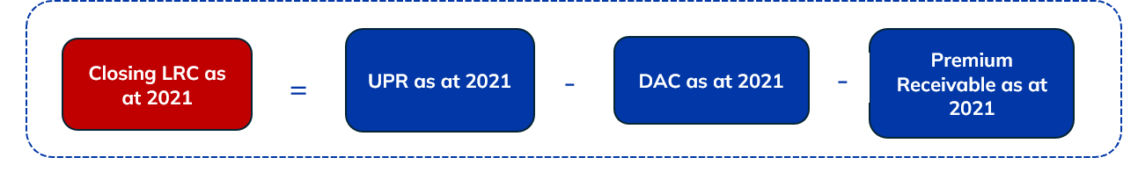
  - The subsequent closing LRC as at 31 December 2022 and 31 December 2023 are computed as follows:
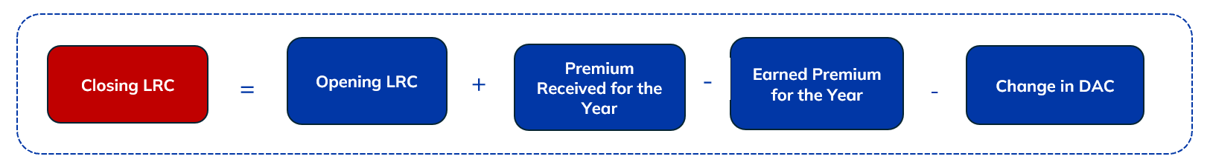
  - For reinsurance, only the reinsurance creditors are included in the LRC. Reinsurance debtors are recognized under the LIC, as recoveries are a claims-related cash flow once a claim event has occurred.
  - Given that group life coverage terms are generally less than 12 months:
- No time value of money or financing component is recognized (IFRS 17.59(b)).
- Interest accretion on the LRC balance is not required.
  - The opening LRC at each reporting date equals the closing LRC of the previous year.

Unearned Premium Reserve Computation
  - Generally, UPR reflects the amount of premiums written but not yet earned. It is the premium corresponding to the time period remaining on an insurance policy and is proportionate to the unexpired portion of the insurance.
  - Unearned premiums are “portions of premiums collected in advance by insurance companies and subject to return if a client ends coverage before the term covered by the premium is complete”.
Determination of UPR
  - We use the 365ths method for calculating UPR for Group Life because the risk exposure is typically assumed to be uniform and constant throughout the policy year for the entire group.

  - The following formula is used to determine Gross UPR:
$$Gross UPR= Total Gross Premium Paid * \frac{Unexpired Period (in Days)}{Policy Duration (in Days)}$$
  - Similarly, Net UPR is estimated using the same approach but using Net Premium instead of Gross Premium. The Net Premium is derived from the data provided, which is the gross premium less reinsurance premiums.

Loss Component
  - This refers to a portion of the LRC that represents future losses expected from a group of insurance contracts.
  - The Loss Component is added to the LRC when a group of insurance contracts is onerous (loss-making).
  - A portfolio is deemed onerous if the Combined Ratio (adjusted for Risk Adjustment factors), exceeds 100%.
  - Portfolios with a combined ratio of less than 100% are considered profitable and therefore no loss component is assigned to them.
  - The loss component is calculated using the formula below:
$$Loss Component=UPR*(Combined Ratio-1)$$

Reinsurance Treatment
  - Reinsurance Creditors (Payables): Included in the LRC.
  - Reinsurance Debtors (Receivables/Recoveries): Recognized under the LIC, as they are claims-related cash flows that arise once a claim event has occurred.

Review and Sign-Off
  - Upon completion of the determination of the Liability for Remaining Coverage, include a summary of any assumptions adopted for review and sign-off.
  - Forward the computations to the reviewing analyst.

CLAIMS RESERVES UTILISATION ANALYSIS

  - Before computing the claims reserves at the current valuation date, it is critical to review the utilisation of past claims reserves. This analysis serves as a feedback loop to validate and refine reserving assumptions.
  - The utilisation of both IBNR and OCR reserves from the past three years should be analyzed. This helps to determine if previous estimates were adequate to cover the claims that subsequently emerged or developed.
  - The claims reserves held at each valuation date is taken from the client’s Accounts and the analysis is done for each year under consideration per class of business.

IBNR Reserve
  - This analysis tracks how much of the IBNR reserve held at a past valuation date (t) was actually used to pay claims reported later (between t+1 and the current valuation date V).
  - The utilisation of the IBNR reserve held at the end of each past year under review as at current valuation date is calculated as follows:
Let:
t = past year under review
U = IBNR utilisation
V = current Valuation Date
Utilisation (U) V = Total Claims incurred in years t and prior but reported in year (t + 1) to V
% Utilisation = U/IBNR t
Where:
Total Claims incurred in years t and prior but reported in year (t + 1) to V
=
Outstanding Claims as at V incurred in years t and prior but reported in year (t + 1) to V
+
Claims Paid in year (t + 1) to V, reported in year (t + 1) to V, but incurred in years t and prior

  - A high utilisation rate might indicate a systemic issue with late claims reporting, while a low rate could signal a consistently overestimated IBNR.

Outstanding Claims Reserves (OCR)
  - This analysis checks if the case-by-case estimates for reported claims (OCR) were sufficient to cover the actual payments that subsequently emerged.
  - Utilisation analysis on the Outstanding Claims Reserve will also be done for the estimates held at the end of each of the past 3 years.
  - Proceed as follows;
Let:
t = past year under review
O = OCR utilisation
V = current Valuation Date
Utilisation (O) V = | Total Outstanding Claims as at V for claims incurred in years t and prior but reported in year (t + 1) to V
% Utilisation = | O/OCR _{t}
IBNER = | OCR _{t} – O _{V}
  - Peculiar utilisation in either case should be investigated. This can be an indication of an anomaly, in which case, claims data can be reviewed for insights or clarification sought from the client.
  - Conduct a trend analysis for the utilisation results over a number of periods to identify a pattern that will guide you in making judgement on the peculiars of the utilisation figures.

LIABILITY FOR INCURRED CLAIMS (LIC)

Data Used in Estimating Claim Liabilities
  - The availability of appropriate and credible data is essential for accurately estimating Group Business claim liabilities. Data may be sourced internally from the insurer’s administration systems, or externally from industry benchmarks and regulatory reports.
  - Large insurers with mature portfolios can primarily rely on their own internal data due to the sufficient volume and detail available.
  - For new products, small insurers, or business in a new geographical region, external data should be incorporated to improve the credibility and reliability of estimates.
  - External data may include statistics from insurers of similar size and risk profile, or publications from regulators and industry associations.
  - When using external data, actuaries should exercise caution, given potential differences in product features, underwriting practices, geographical context, and mix of business (e.g., mortality vs. morbidity benefits)
  - Any external data sources must be disclosed, with justification documented in the reserving model for peer review.
Homogeneity and Credibility of Data
  - Group life claims exhibit different patterns depending on the benefit type.
  - At a minimum, reserving should be done on a class-of-business basis (e.g., Group Life, Group Credit, Group Last Expense).
  - Data can be further subdivided or aggregated based on volume and credibility. Document the rationale for any such groupings.
  - Key characteristics for separating group life data for reserving include:
    - Consistency of coverage and policy terms.
    - Volume of claim counts within the group.
    - Reporting pattern (time lag between loss and notification)
    - Settlement pattern (time to finalize payments)
    - Average claim amount (severity).

Paid, Outstanding and Incurred Claims Data
  - Incurred claims include both paid (claims that have already been settled) and outstanding claims (insurer has been notified about but are yet to be settled).
  - Professional judgement is required in deciding the type, source, and volume of data used, as well as in determining homogeneity. Assumptions and rationale must be reviewed and approved by the peer reviewer and/or supervisor.

Claims Reserving
  - Claims reserves represent the insurer’s best estimate of liabilities for claims that occurred on or before the valuation date but are unpaid.
  - The reserving process follows a four-phase approach:
- Validate and balance the claims data against accounts and identify anomalies. Refer to the Valuation Data & Checks Manual for guidance.
- Apply at least two suitable methods for each homogenous group.
- Compare, reconcile, and explain results from different methods.
- Monitoring projections of claims development over subsequent calendar periods. Deviations of actual development from projected development of counts or amounts are one of the most useful diagnostic tools in evaluating the accuracy of claims liabilities estimates.
  - This manual focuses on the second phase by providing guidance on the various techniques to use in the reserving process.
  - Claim reserves are set aside for two main types of claims:
- outstanding reported claims; and
- incurred but not reported claims (IBNR).

General Steps in Reserving
  - Ensure data is complete (Paid, Outstanding, Incurred claims).
  - Review and re-classify data into homogenous groups as needed.
  - Plot gross claims amounts to identify extreme values (outliers).
  - Exclude these outliers from the core reserving analysis to prevent distortion.
  - Incorporate a loading to the final reserves based on the observed proportion of large losses, as these occurrences may be repetitive.
  - Use the adjusted data to develop run-off/delay triangles.
  - Identify and gain sign-off on at least two key reserving methods for each homogenous group.
  - The final step will be generation of the draft valuation report, in the prescribed format, which is further subjected to peer review.
  - The Actuarial Manager will be in charge of communicating the results with the client and once these are finalised, a final valuation report will be prepared and submitted to the client under the directive of the Lead Actuary.
Overview: Run-off Triangles
  - Run-off/delay triangles are important for forecasting future claims amounts.
  - They are important when there may be a time lag after the loss until the full extent of the claims which have to be paid are known. They provide a method of tabulating claims data and studying the underlying statistical model.
  - The period in which a loss happens, and the insurer was on risk is called the accident/loss period. This may be categorized as years or quarters, or any other identified period chosen to study the claims.
  - The number of periods until a payment is made is called the delay, or development period. The cumulative claims data is divided up by the accident/loss period and the development period. An example of classification is as shown in the figure below.
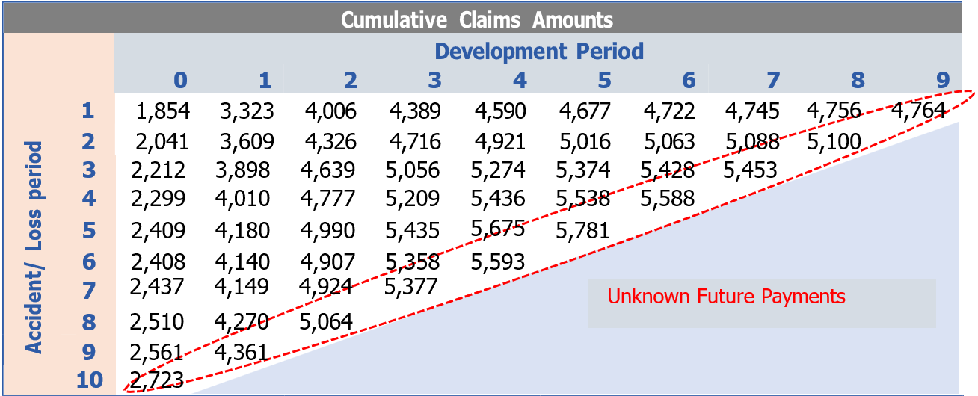
  - Each row in the triangle represents an origin period which defines a cohort of claims while the columns represent development periods, which show how the cohort of claims relating to a particular origin period develop over time.
  - Note that particular periods are represented by the diagonals in the triangle. For example, the circled diagonal includes all payments made during the most recent period shown, i.e. period 10, which could be the recent period (as well as past periods since the triangle contains cumulative entries).
  - Also note that the upper left corner represents ‘known’ past claims amounts, while the lower right corner represents ‘unknown’ future amounts. The main aim of reserving is to look at methods of estimating the unknown figures to complete the lower right triangle.
  - For each accident/loss period, the difference between the figure in the extreme right-hand column and the total amount paid so far will give us the estimate of the amount we need to hold currently to meet future liabilities arising.
  - Claims are analysed in cohorts, and it is important that each claim is allocated to the correct cohort.
  - One method of recording data is by accident-period basis where claims development is clustered by the period an accident/loss has occurred. In that respect, such data would include incurred but not yet reported (IBNR) claims.
  - Claims paid in the period the accident/loss takes place are said to be paid in development period 0, claims paid in the following period are said to be paid in development period 1 and so on. The proportion of payments in various development period arising from the losses in an accident/loss period is known as the Loss Development Pattern.
  - Classes of insurance for which the Loss Development Pattern spreads out over a number of development period (such as Liability Insurance) are said to be Long Tail Business while classes of insurance for which the Loss Development Pattern is short (such as Fire and Theft Motor) are said to be Short Tail Business.
  - Another method of recording data is by underwriting period. This procedure would group claims by the time policies were written rather than when they occurred. This method would therefore include IBNR claims, and claims that are yet to occur, if they relate to a policy written in the underwriting period.
  - A third method of grouping claims is by reporting period. This method would not include IBNR claims as all claims would be allocated to the period in which they were reported.
Projections using Development Factors
  - An insurer's liabilities for outstanding claims at a given date (the valuation date) are the present value of claim payments, to be made after the valuation date, on claims which, under the terms of its contracts, arose on or before the valuation date plus the present value of the insurer's internal costs directly related to administering and settling those payments.
  - The basic assumption made in estimating outstanding claims liabilities concerns the run-off pattern. The simplest assumption is that claims will emerge in a similar way in each accident/loss period. The proportionate increases in the known cumulative claims from one development period to the next can then be used to calculate the expected cumulative claims for future development periods.
  - Note that the ratios that are used to project future claims are known as development factors or link ratios.
  - A development factor may describe the ratio between cumulative claim amounts in consecutive periods or between periods over a longer period.
  - In the table below we calculate development factors for the ratios between consecutive periods. For example, the development factors in the highlighted column are derived by dividing the cumulative payments in column 1 by the corresponding payments in column 0.
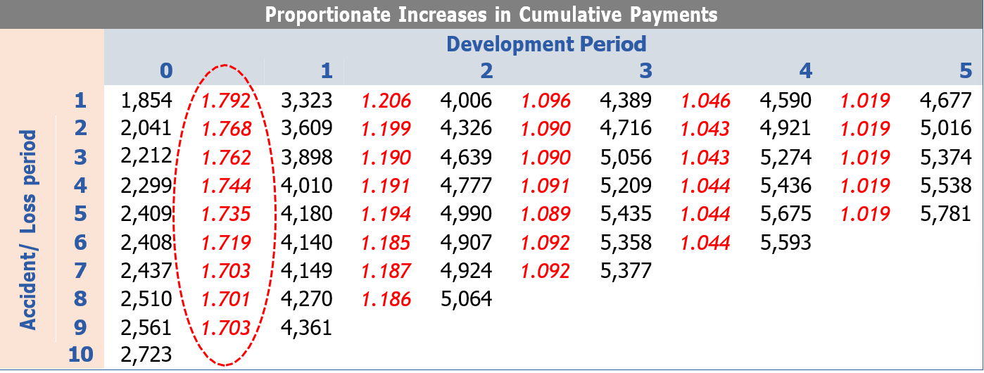
  - For each accident/loss period there is a different ratio for the increase in cumulative payments from development period 0 to development period 1.
  - The development factors will always be greater than or equal to 1.
  - The choice on which development factor to apply when projecting forward for accident/loss period 10 is subject to judgement. For example, for a conservative approach, it might be best to take the largest ratio, i.e. 1.792. Other options are using the lowest ratio, a simple average or weighted average of the ratios.

Valuation Methods
  - Methods that are used to value the insurance liability for each class are prescribed in the guidelines issued in Legal Notice No. 37 to the Insurance Act, issued through Kenya Gazette Supplement No. 34 of 24 March 2017, and are listed in the section to follow.
  - The methods used to calculate the insurance liabilities are shown below:
    - Outstanding Claims Reported (OCR): Case Estimate Method;
    - Incurred But Not Reported (IBNR): Chain Ladder, Bornhuetter-Ferguson, Cape Cod (Standard-Buhlmann), Expected Loss Ratio and Standard Development Method;
    - Unearned Premium Reserve (UPR): ‘365ths’ method for gross premium;

IBNR Computation
  - Reserves are computed using the Basic Chain Ladder (BCL), the Bornhuetter-Ferguson (BF), Loss Ratio (LR) and the Cape Cod methods on either quarterly basis or annual basis.
  - The choice of method used for each class is guided by the availability of credible volume of data.
  - Under the Basic Chain Ladder (BCL) method, reported claims data are displayed in the development triangles and age to age factors calculated. For each payment lag, average age to age factors is computed which are used to get cumulative development factors (CDF). The cumulative development factors show the development pattern of the claims that help project ultimate claims using a triangulation approach.
  - The Bornhuetter-Fergusson (BF) method is a blend between the basic chain ladder method and what is expected based on the recent experience of the class. In this method, historical experience is retained as part of the estimate of ultimate claims but is not the basis from which future claim activity is projected. Instead, we derive future claim activity from a priori estimate of our expectation.
  - The Bornhuetter-Fergusson method is adopted where there is uncertainty in the claims development trends. In this regard, the basic chain ladder method depends on the stability of claims development. The Bornhuetter - Fergusson method considers both the claims developed to date (which depends on reporting/payment patterns) and the expected claims based on recent experience of the class, hence improving the accuracy of the estimate.
  - The Cape Cod method assumes a constant ultimate loss ratio for each past accident years. The ultimate loss ratio is estimated by dividing the reported losses for all years by the reported exposures. The exposure is estimated by multiplying the exposure measure by the percentage of losses that have developed. Earned premiums are used as the exposure measure. The reserve is then estimated as the percentage of unreported expected ultimate claims.
  - The Expected Loss Ratio method projects ultimate claims relative to earned premiums, based on expected loss ratios. This method is employed for classes where past data available is considered inadequate for triangulation.
  - IBNR is calculated as the projected ultimate claims less actual claims incurred to date.

Adjustments to Claims Data
  - Appropriate adjustments are made for large claims/outliers that are expected to distort the estimated development of future claims.
  - Where adjustments are made in the data used for large/outlier claims, consideration are further taken of whether such experience can be reasonably expected to recur in future and the expected impact on claims. Where applicable, explicit loadings are made in future reserve estimates.

Risk Adjustment
  - The Risk Adjustment (“RA”) is the compensation an entity requires for bearing the uncertainty about the amount and timing of the cash flows that arise from non-financial risk as the entity fulfils insurance contracts.
  - The Bootstrapping method is used to calculate the Risk Adjustment as at the Valuation Date.
  - The Bootstrapping method is a statistical technique that resamples historical claims data to generate a distribution of possible future outcomes, allowing for a detailed and realistic estimation of the RA. It uses a two-stage bootstrapping approach.
  - In the first stage an ordinary Basic Chain Ladder (“BCL”) method is applied to a cumulative claim’s triangle. The calculated the scaled Pearson residuals are bootstrapped R times to forecast future incremental claims payments via the standard BCL method.
  - In the second stage, a simulation process error is run using the bootstrap value as the mean and assuming over-dispersed Poisson process distribution. The IBNR reserves generated by this technique form the predictive distribution from which summary statistics including the mean, prediction error, and quantiles can be computed.
  - This resampling technique utilizes historical data to generate stochastic scenarios, drawing upon past observations as potential future outcomes rather than theoretical distributions. This results of the production of a full distribution of the claims from which the mean and the 75th percentile reserves will be estimated. The Risk Adjustment is then derived from the two estimates as shown below:
$$Risk Margin at 75\% Confidence Level=IBNR at 75\% Confidence Level- Mean IBNR$$

APPENDICES

Appendix 1: Sign-Off Template

Sign-off
Statement by the Lead Analyst
I confirm that I have carried out this work in line with the applicable KAFS Internal Technical Policy and Procedure. Below is a summary of the key assumptions made:
Key Assumptions
1
2
3
4
5
Name:
Date:
Statement by Peer Reviewer
I have reviewed this work in line with the KAFS Work Review Policy and discussed all issues encountered with the Lead Analyst. Below are my review comments:
Review Comments
1
2
3
4
5
Name:
Date:
Statement by Supervisor
I have reviewed this work and discussed the issues encountered and the key assumptions made by the Lead Analyst. I confirm that the results are in order.
Name:
Date:

APPROVAL
Thus, adopted and signed by the management and Chief Actuary of KAFS in January 2026.
APPROVED BY
Ezekiel Macharia
Chief Actuary & Managing Director – Kenbright Actuarial and Financial Services Limited

Date: January 2026
Signed:

This page has been left intentionally blank



About Us

Kenbright Actuarial & Financial Services Limited (KAFS)
Prism Towers, 26th Floor
3rd Ngong Avenue, Nairobi
Kenya
www.kenbright.co.ke

Customer Service Lines: +254 (020) 22 111 52

Document Version

January 2026

Version 1.0: Creation

Reproduction – in total or in part – only with the permission of KAFS.

Key Contacts

E Macharia, FIA C.Act, FeASK
Chief Actuary & Managing Director
E-mail: ezekiel@kenbright.africa
Phone: +254 722 540 045

